Exercise: Spring Data JPA with Hibernate Part 2

JPQL:

1. Display the first name, last name of all employees having salary greater than average salary ordered in ascending by their age and in descending by their salary.

Answer:



1. Update salary of all employees by a salary passed as a parameter whose existing salary is less than the average salary.

Answer:

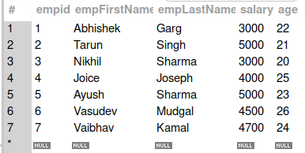

Before Updation

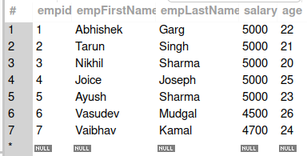

After Updation

1. Delete all employees with minimum salary.

Answer:



Before Deletion

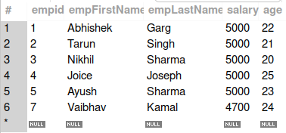

After Deletion

Native SQL Query:

1. Display the id, first name, age of all employees where last name ends with "singh"

Answer:



1. Delete all employees with age greater than 45(Should be passed as a parameter)

Answer:

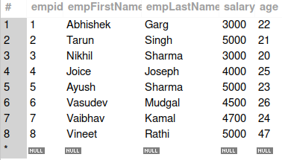

Before Deletion

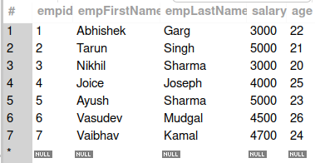

After Deletion

Inheritance Mapping:

1. Implement and demonstrate Single Table strategy.

Answer:

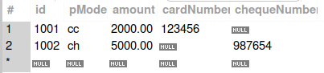

1. Implement and demonstrate Joined strategy.

Answer:

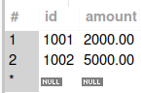





1. Implement and demonstrate Table Per Class strategy.

Answer:





Component Mapping:

1. Implement and demonstrate Embedded mapping using employee table having following fields: id, firstName, lastName, age, basicSalary, bonusSalary, taxAmount, specialAllowanceSalary.

Answer:

